**Internet of Things**

|  |
| --- |
| **UNIT 5**: **IoT Physical Devices and Endpoints** |
| Introduction to Apache Hadoop, Hadoop MapReduce for Batch Data Analysis, Apache oozie, Apache Spark, Apache Storm. |

**1. Introduction to Hadoop**

1.1 Overview of Big Data Big Data refers to the vast amount of structured, semi-structured, and unstructured data generated at high velocity, from a variety of sources. Traditional data processing tools are often insufficient to handle, store, or analyze such large and complex datasets. Big Data is characterized by the 3 Vs:

- Volume: Refers to the enormous amount of data generated.

- Velocity: The speed at which data is created, processed, and analyzed.

- Variety: The diversity of data types, including structured (databases), semi-structured (XML), and unstructured (text, images, video).

Big Data technologies enable the extraction of insights from vast datasets and are used across industries for decision-making, forecasting, and improving operational efficiency

**1.2 What is Hadoop?**

Hadoop is an open-source framework used to store and process large datasets across distributed clusters of computers. It is designed to handle the challenges of Big Data, making it scalable, fault tolerant, and cost-effective. The core components of Hadoop include: - HDFS (Hadoop Distributed File System): A distributed file system that splits large files into smaller chunks and stores them across multiple machines. - MapReduce: A programming model for processing and generating large datasets in parallel. Hadoop allows businesses to handle Big Data without requiring costly proprietary hardware or specialized software, using commodity hardware instead.

**1.3 Importance in Big Data Processing**

Hadoop plays a crucial role in Big Data processing because of its ability to

* Scale: It can efficiently store and process petabytes of data across clusters of machines.
* Ensure Fault Tolerance: Data is replicated across multiple nodes, so it is not lost if a machine fails.
* Handle Multiple Data Types: Hadoop supports the storage and analysis of structured, semistructured, and unstructured data.
* Reduce Costs: As an open-source framework, Hadoop is cost-effective, and it works well with commodity hardware.
* Parallel Processing: Through MapReduce, Hadoop can process data in parallel, drastically reducing the time needed for large-scale computations.

**2. Evolution and Versions of Hadoop**

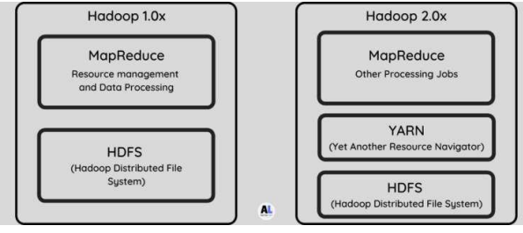

**2.1 Hadoop Version 1.x**

Hadoop Version 1.x was the original version of the framework, which provided basic functionality for storing and processing large datasets across distributed clusters. It consisted of two key components: - HDFS (Hadoop Distributed File System): A distributed storage system designed to store large datasets by splitting them into smaller blocks and distributing them across multiple machines. - MapReduce: A processing model for handling large-scale data in parallel. The data processing was divided into two stages: the Map stage (which processes input data) and the Reduce stage (which aggregates the results). However, Hadoop 1.x had several limitations, notably: - JobTracker: The JobTracker was responsible for both job scheduling and resource management. This centralized approach created a bottleneck, as the JobTracker became overwhelmed with requests, especially in large clusters. - Scalability Issues: As the size of the clusters grew, the centralized management of resources and scheduling became inefficient, limiting the scalability of the system.

**2.2 Hadoop Version 2.x**

Hadoop Version 2.x addressed the shortcomings of Version 1.x by introducing several significant improvements and new features: - YARN (Yet Another Resource Negotiator): YARN replaced the JobTracker and provided a more flexible and scalable resource management system. YARN decouples the job scheduling and resource management functions, allowing different processing frameworks (like MapReduce, Apache Spark, etc.) to run on the same cluster. It enhances resource utilization and scalability. - HDFS Improvements: Version 2.x introduced HDFS Federation, which allowed multiple namespaces, improving the scalability and performance of the distributed file system. - Enhanced Fault Tolerance: Improvements in the handling of failures and data replication mechanisms made Hadoop 2.x more robust and reliable than Version 1.x.

With these improvements, Hadoop 2.x became more scalable, flexible, and capable of handling a broader range of workloads, including real-time processing and more complex computations beyond MapReduce.

**2.3 Key Differences and Enhancements (e.g., YARN)**

The key differences between Hadoop Version 1.x and Version 2.x are: - Resource Management: In Version 1.x, the JobTracker was responsible for both scheduling and resource management, creating a bottleneck. With Version 2.x, YARN separates these responsibilities, providing better resource utilization and scalability. - Scalability: Hadoop 2.x improved scalability through the use of YARN and HDFS Federation, allowing it to support larger clusters and more complex workloads. - Processing Flexibility: While Hadoop 1.x was limited to MapReduce, Version 2.x supports multiple processing frameworks like Apache Spark, Apache Tez, and others, allowing for greater flexibility in data processing. - Fault Tolerance: Hadoop 2.x introduced more advanced fault tolerance mechanisms, improving the overall reliability and availability of data across the cluster.

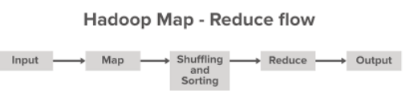

**3. Understanding MapReduce**

**3.1 Definition and Functionality**

MapReduce is a programming model and processing technique designed to process large datasets in a distributed manner across a Hadoop cluster. It is based on two key operations: - Map: The input data is divided into smaller chunks and distributed across multiple nodes. Each chunk is processed by a Map function, which produces intermediate key-value pairs. - Reduce: After the Map phase, the intermediate key-value pairs are shuffled and grouped by key. The Reduce function then processes these groups to generate the final output. MapReduce allows for parallel data processing, making it ideal for handling large-scale data on distributed systems. It abstractsthe complexity of distributed computing, providing a simple model for developers to write parallel programs.

3.2 **MapReduce Programming Model**

The MapReduce model consists of the following steps: - Input Splitting: The input data is divided into smaller, manageable chunks (usually called splits) that are processed in parallel across multiple nodes. - Mapping: Each split is processed by a Map function. This function takes input data, applies a user-defined logic, and generates intermediate key-value pairs. - Shuffling: The intermediate key-value pairs are then grouped by key. This process ensures that all values associated with the same key are brought together on the same node. - Reducing: The Reduce function takes each group of key-value pairs and aggregates or processes the data to generate the final output. - Output: The final results are written to a distributed file system, typically HDFS.

3.3 **Phases of MapReduce**:

Map, Shuffle, and Reduce The MapReduce process can be broken down into three main phases: - Map Phase: In this phase, the input data is split into smaller chunks, and the Map function is applied to each chunk. The Map function generates key-value pairs. - Shuffle Phase: After the Map phase, the system performs the shuffle, where the intermediate key-value pairs are sorted and grouped by key. This ensuresthat all data for the same key is brought together for further processing. - Reduce Phase: In the Reduce phase, the system processes the grouped data by applying the Reduce function. The output is a final set of key-value pairs that represent the processed results. MapReduce allows for efficient, parallel data processing by dividing the work into smaller units that can be executed concurrently across multiple nodes in the Hadoop cluster.

**4. Characteristics of MapReduce**

• Distributed Processing MapReduce is fundamentally designed for distributed computing, enabling parallel processing of large datasets across multiple machines. This allows computation to be spread across numerous nodes in a cluster, dramatically improving processing speed and handling of massive data volumes.

• Fault Tolerance The framework is inherently resilient to hardware failures. If a processing node fails during computation, the MapReduce system automatically redistributes the failed task to another available node. This ensures that the overall computation continues smoothly without manual intervention, providing robust and reliable data processing.

• Data Locality Optimization MapReduce prioritizes processing data on the same node where it is stored, minimizing network transfer overhead. By moving computation closer to the data rather than moving data to the computation, the system significantly reduces network bandwidth consumption and improves overall processing efficiency.

• Scalability The architecture allows seamless horizontal scaling. Organizations can add more commodity hardware to the cluster to increase processing capacity, enabling linear performance improvements as computational resources are expanded.

• Simplification of Parallel Programming Developers can focus on writing Map and Reduce functions without managing complex distributed computing details. The framework handles intricate aspects like task scheduling, synchronization, and inter-node communication automatically.

• Key-Value Pair Transformation The programming model fundamentally transforms input data into key-value pairs, facilitating efficient sorting, grouping, and aggregation of large datasets through a standardized processing approach.

• Automatic Parallelization MapReduce transparently parallelizes computational tasks, dividing input data into independent chunks that can be processed simultaneously across multiple nodes without explicit parallel programming.

• Hardware Independence The framework is designed to run efficiently on commodity hardware, eliminating the need for expensive, specialized computing infrastructure.

• Flexible Data Processing While originally designed for batch processing, MapReduce can handle various data types and supports complex transformations across structured and unstructured data sources.

**5. Features of Hadoop**

5.1 Distributed Storage and Computing Hadoop's HDFS (Hadoop Distributed File System) allows data to be distributed across many nodes in a cluster, ensuring that large datasets can be stored efficiently. The distributed nature of both storage and computing allows Hadoop to store and process massive amounts of data. HDFS splits files into blocks and stores them across various nodes, while the MapReduce framework enables distributed processing of data on those same nodes. This approach allows Hadoop to handle terabytes to petabytes of data.

5.2 Scalability and Flexibility Hadoop is designed to be highly scalable, allowing it to grow seamlessly as data volume increases. Organizations can easily add more nodes to a Hadoop cluster to scale both storage and processing capacity. Hadoop also offers flexibility in terms of the data types it can handle—whether structured, semi-structured, or unstructured. This makes Hadoop adaptable to a wide range of data processing tasks, from batch processing to real-time analysis.

5.3 Fault Tolerance and High Throughput Hadoop is built for fault tolerance. Data in HDFS is replicated across multiple nodes, which ensures that even if a node fails, the data is not lost and can still be accessed from other replicas. Additionally, the Hadoop ecosystem is designed for high throughput, meaning it can process large volumes of data quickly and efficiently. The combination of fault tolerance and high throughput makes Hadoop a reliable and robust platform for Big Data processing.

**6. Components of Hadoop**

6.1 HDFS (Hadoop Distributed File System) HDFS is the primary storage system of Hadoop. It is designed to store large datasets across multiple machines in a distributed fashion. Key characteristics of HDFS include: - Block-based Storage: Data is split into blocks (typically 128MB or 256MB) and distributed across the nodes in a cluster. - Data Replication: Each block is replicated multiple times (usually 3), ensuring data availability in case of node failure. - Master-Slave Architecture: HDFS uses a master-slave architecture, with the NameNode acting asthe master and responsible for managing metadata, and the DataNodes acting asslaves that store the actual data blocks. HDFS ensures high throughput access to data and is optimized for large-scale data processing rather than transactional data operations.

6.2 YARN (Resource Negotiator) YARN is Hadoop's resource management layer introduced in Hadoop 2.x to addressthe limitations of the JobTracker in Version 1.x. YARN separates resource management from job scheduling, providing a more flexible and scalable architecture for running different types of processing applications. Its main components include: - ResourceManager: Manages the resources across the cluster, allocating resources to various applications. - NodeManager: Runs on each node and manages the execution of tasks assigned to that node. - ApplicationMaster: Responsible for the execution of a single application, negotiating resources and monitoring the application's progress. YARN allows Hadoop to support a variety of processing frameworks, such as MapReduce, Spark, and others, by providing a unified resource management platform.

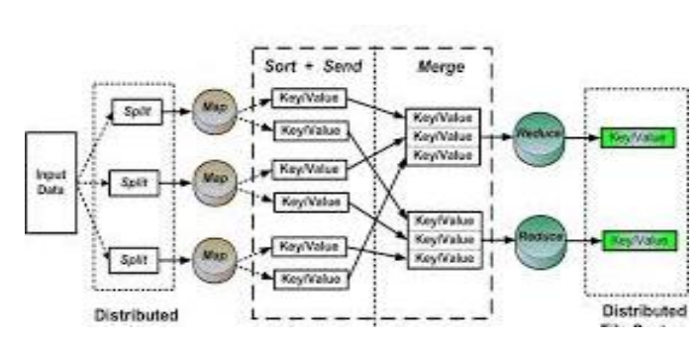

**6.3 MapReduce Framework**

The MapReduce framework is responsible for processing large datasetsin parallel across a Hadoop cluster. It follows the Map-Reduce programming model, where data is divided into chunks, processed in parallel by mappers, and then aggregated by reducers. Key components of MapReduce include: - JobTracker (Version 1.x): Managed job scheduling and resource allocation (replaced by YARN in Version 2.x). - TaskTracker (Version 1.x): Monitored the execution of individual tasks (also replaced by YARN). In Hadoop 2.x, the MapReduce framework runs as an application on YARN, which manages the distribution of tasks across the cluster, making it more scalable and flexible.

**6.4 Additional Components**

Hadoop ecosystem includes several other tools and frameworks to support a wide variety of Big Data use cases: -

Hive: A data warehouse system that provides an SQL-like query language (HiveQL) for querying and managing large datasets in HDFS. It abstracts the complexities of Hadoop's low-level API and simplifies data analysis for users familiar with SQL. –

Pig: A high-level platform that simplifies data processing through a scripting language called Pig Latin. Pig is used for handling tasks such as data transformation and processing of complex datasets. - HBase: A distributed, NoSQL database built on top of HDFS.

HBase is designed for real-time read/write access to large datasets, providing a way to store structured data in a scalable and faulttolerant manner.

Zookeeper: A centralized service for maintaining configuration information, naming, synchronization, and group services across distributed applications. It is often used to coordinate and manage the services in the Hadoop ecosystem.

Sqoop: A tool for efficiently transferring bulk data between Hadoop and relational databases.

Flume: A service for collecting, aggregating, and moving large amounts of log data into Hadoop.

These components work together within the Hadoop ecosystem to provide end-to-end solutions for Big Data storage, processing, and analysis.

7. Working Flow of Hadoop Ecosystem

**7.1 Data Ingestion, Storage, and Processing**

The Hadoop ecosystem follows a series of steps to ingest, store, and process data:

1. Data Ingestion: - Data is first ingested into the Hadoop system through tools like Flume, Sqoop, or custom ingestion scripts. These tools capture data from various sources such as log files, relational databases, and streaming data. - Once ingested, data is stored in HDFS, which provides a distributed and fault-tolerant storage layer.

2. Storage: - HDFS splits the data into blocks and stores them across multiple nodes in the cluster. Each block is replicated multiple times to ensure fault tolerance. - The data is stored in its raw form and can later be processed or transformed by various tools in the ecosystem. 3. Processing: - Once the data is stored, processing can be done using MapReduce (for batch processing) or Apache Spark (for real-time processing). - The YARN resource manager schedules and allocates resources for processing tasks across the cluster.

**7.2 Role of HDFS and MapReduce**

HDFS and MapReduce are the core components of the Hadoop ecosystem for storage and processing: - HDFS handlesthe storage of large datasets across a distributed cluster. It ensures data redundancy and fault tolerance by replicating blocks of data. - MapReduce handles the processing of large datasets by dividing tasks into smaller chunks that can be processed in parallel across different nodes. Data is moved through the system by the Map and Reduce phases.

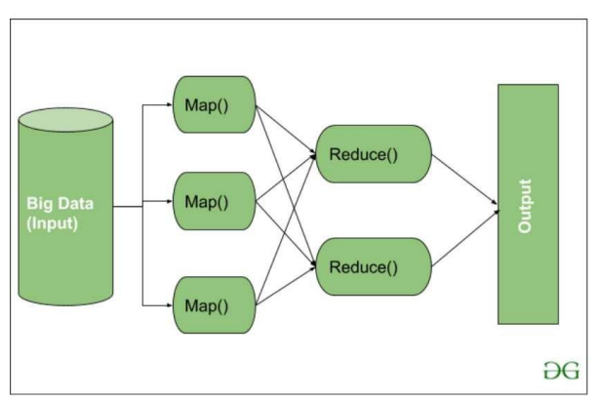

**7.3 Data Analysis and Reporting**

Once the data is ingested, stored, and processed, it can be analyzed and reported using various tools: - Hive can be used for running SQL-like queries over large datasets stored in HDFS. It abstracts Hadoop's complexity and allows analysts to query data using a familiar interface. - Pig simplifies complex data transformations by using its high-level scripting language. - HBase provides a way to store and query real-time data, allowing for low-latency access to data. - Visualization Tools (e.g., Tableau or custom dashboards) can be integrated to visualize the results of the analysis. The processed data is used for reporting, decision-making, and generating insights for various business applications.

**8. Hadoop vs Other Big Data Frameworks**

8.1 Hadoop vs Spark, Flink, NoSQL - Hadoop vs Spark: -

Hadoop is a batch-processing framework primarily based on the MapReduce programming model, which processes large datasets in parallel. It works well for batch-oriented tasks where the computation can be broken into distinct steps (Map and Reduce).

- Spark is a distributed processing system designed for speed and real-time analytics. Unlike Hadoop's MapReduce, which writes intermediate results to disk, Spark processes data in-memory, significantly speeding up computations. It supports batch processing, real-time streaming, machine learning, and graph processing. Spark is often preferred for iterative algorithms (e.g., machine learning) and real-time data processing due to its performance advantages over Hadoop MapReduce.

- Hadoop vs Flink: - Flink is another stream-processing framework, designed for real-time, low-latency analytics. While Hadoop is designed for batch processing, Flink excels in handling unbounded data streams with high throughput and low latency. Flink provides powerful stateful processing and supports both batch and stream processing with consistent results. - Flink vs Spark: Flink is generally better for true stream processing, while Spark (with its structured streaming module) is more often used for micro-batch processing.

- Hadoop vs NoSQL: - Hadoop is a distributed framework for batch processing and data storage (via HDFS), suitable for analytical workloads. It is commonly used for processing large datasets and performing operations that require high throughput. - NoSQL databases (e.g., MongoDB, Cassandra) are designed for real-time data retrieval and are optimized for read and write-heavy applications that require low-latency operations. NoSQL databases typically handle unstructured data and are more flexible in schema management. While Hadoop is suited for large-scale analytics, NoSQL is better for transactional systems and real-time applications.

**8.2 Comparison with Traditional Databases –**

**Traditional Databases:** Traditional relational databases (e.g., MySQL, Oracle) are designed to handle structured data, ensuring ACID (Atomicity, Consistency, Isolation, Durability) properties, which are essential for transaction processing. These databases scale vertically by adding more power (CPU, memory) to a single machine. - Hadoop: In contrast, Hadoop is designed to handle big data — large volumes, high velocity, and complex types of data, such as unstructured or semi-structured data. It scales horizontally, adding more machines to the cluster rather than upgrading a single machine. Hadoop provides a distributed architecture, where computation is performed across a large cluster of machines, whereas traditional databases often struggle with scalability and performance when faced with petabytes of data.

**- Key Differences:**

- Data Model: Traditional databases use a structured data model with tables, rows, and columns, while Hadoop can handle structured, semi-structured, and unstructured data.

- Scaling: Traditional databases scale vertically (more power to one machine), while Hadoop scales horizontally (adding more machines).

- Use Cases: Traditional databases are optimized for OLTP (Online Transaction Processing), whereas Hadoop is optimized for OLAP (Online Analytical Processing), making it suitable for large-scale data processing and analytics.

**9. Benefits of Hadoop**

9.1 Scalability, Cost-Effectiveness, Fault Tolerance

- Scalability: Hadoop's architecture allows it to scale horizontally by adding new nodes to the cluster. As data volumes grow, more machines can be added to handle the increased load. This makes Hadoop suitable for enterprises that handle vast amounts of data, as it can scale from small setups to petabyte-scale systems.

- Cost-Effectiveness: Hadoop runs on commodity hardware, meaning it does not require expensive, specialized infrastructure. This makes it a cost-effective solution for Big Data processing. Additionally, as Hadoop is open-source, organizations can avoid the licensing costs associated with proprietary software.

- Fault Tolerance: Hadoop's HDFS ensures that data is replicated across multiple nodes, so if one node fails, data is still available from other replicas. Similarly, Hadoop’s MapReduce framework is fault-tolerant: if a task fails, it can be re-executed on another node without disrupting the overall job.

**9.2 High Availability and Efficient Data Processing**

- High Availability: Hadoop ensures high availability through the replication of data across multiple nodes in HDFS. In case of node failure, the data can be retrieved from another replica without affecting processing. Additionally, YARN’s resource management ensures that tasks are rescheduled in case of a failure, minimizing downtime.

- Efficient Data Processing: Hadoop’s distributed architecture allows for parallel processing, which speeds up data processing significantly. Large datasets are broken into smaller chunks and processed in parallel across multiple nodes, enabling faster computation than traditional systems.

**10. Applications of Hadoop**

**10.1 Data Warehousing, Machine Learning, Log Analysis**

- Data Warehousing: Hadoop serves as a cost-effective and scalable data warehouse solution. It can store vast amounts of raw data and support analytical tools such as Hive and Pig to query and analyze that data. Businesses use Hadoop for aggregating data from varioussources and transforming it into valuable insights.

- Machine Learning: Hadoop provides a powerful platform for machine learning applications. With frameworks like Apache Mahout or Apache Spark MLlib, Hadoop can be used to build predictive models on large datasets. It supports distributed machine learning algorithms, making it possible to handle Big Data in machine learning workflows.

- Log Analysis: Hadoop is widely used for log analysis due to its ability to store and process vast amounts of log data from various systems, applications, and devices. Using tools like Apache Flume or Sqoop, log data can be ingested into Hadoop and analyzed using MapReduce or Spark for performance monitoring, security analysis, or troubleshooting.

**10.2 Real-Time Processing, Fraud Detection, Recommender Systems**

- Real-Time Processing: While Hadoop was initially designed for batch processing, frameworks like Apache Kafka, Apache Flink, and Apache Storm have been integrated with Hadoop to enable real-time data streaming and processing. This makes it suitable for applications that require immediate insights, such as monitoring systems, fraud detection, and IoT analytics.

- Fraud Detection: Hadoop is used in fraud detection systems, particularly in banking and finance, to analyze large datasets for patterns or anomalies that may indicate fraudulent activity. With the ability to handle real-time data, Hadoop can help detect fraud as it happens, allowing businesses to act quickly.

- Recommender Systems: Hadoop is commonly used in recommender systems, such as

those used by e-commerce platforms like Amazon and Netflix. It processes vast amounts of user data to create personalized recommendations based on past behaviors and preferences. Hadoop can handle the scale required to analyze user activity and generate recommendations for millions of users simultaneously

**11. Challenges of Hadoop**

11.1 Complexity, Hardware Requirements, Data Security

- Complexity: Hadoop is a complex system, and setting it up requires specialized skills. Configuring Hadoop clusters, optimizing MapReduce jobs, managing failures, and ensuring efficient data processing can be challenging. The vast ecosystem of tools and components (like Hive, Pig, and HBase) also adds to the complexity of Hadoop, requiring administrators to have expertise in both hardware and software.

- Hardware Requirements: Hadoop’s performance depends heavily on the hardware infrastructure it runs on. As Hadoop scales horizontally, managing a large number of nodes becomes increasingly challenging. Each node must be equipped with sufficient storage, memory, and processing power to handle Big Data workloads. Furthermore, maintaining hardware redundancy for fault tolerance and load balancing requires careful planning and management.

- Data Security: Hadoop is often used in environments where sensitive data is processed. As data is distributed across multiple nodes, ensuring the security of the data is challenging. Implementing proper encryption, access control, and auditing is essential to ensure data privacy and regulatory compliance. Hadoop provides some security features, but securing the entire ecosystem (especially in multi-tenant environments) requires careful planning and additional tools like Apache Ranger or Knox for authentication and authorization.

**11.2 Job Management and Integration with Legacy Systems**

- Job Management: Managing and scheduling MapReduce jobs in a large Hadoop cluster can be cumbersome. Although YARN has improved job scheduling in Hadoop, handling job priorities, dependencies, and resource allocations across a large cluster still requires significant overhead. Job failures and retries can further complicate the process, and optimizing job performance often involves finetuning configuration settings.

- Integration with Legacy Systems: Integrating Hadoop with legacy systems (such as traditional relational databases, ERP systems, and on-premise applications) can be difficult due to differences in data formats, data structures, and architectures. Often, organizations need to use additional tools such as Sqoop (for importing/exporting data between Hadoop and relational databases) or Flume (for ingesting log data) to bridge the gap. These integrations can add complexity and increase the overall management burden.

**Apache Oozie: Introduction**

* **Apache Oozie** is a workflow scheduler system that enables the management and coordination of Hadoop jobs, particularly when multiple MapReduce jobs need to be chained for data analysis.
* It allows users to define workflows as collections of actions, arranged in Directed Acyclic Graphs (DAGs), where each action is executed only after the preceding one completes.
* Workflows are defined using an XML-based Process Definition Language called hPDL.
* Oozie supports a variety of actions, including Hadoop MapReduce, Pig, Hive, Sqoop, Java, email, shell commands, and custom actions, making it a versatile tool for orchestrating complex data processing tasks in Hadoop environments.

**Apache Oozie: Features**

* **Time-triggered and event-triggered workflows**

Oozie schedules workflows based on time or data availability. This flexibility makes it suitable for complex pipelines.

* **Seamless integration with Hadoop ecosystem tools**

Oozie works natively with tools like Hive, Pig, and HDFS, enabling efficient orchestration of Hadoop jobs

* **Error handling and Fault tolerance**

Oozie automatically retries failed jobs and handles errors ensuring workflow continuity.

* **High scalability and reliability**

Oozie can scale to manage workflows across large clusters. Its robust architecture ensures consistent performance in distributed environments.

**Apache Oozie: Architecture**

1. **Client**: Interface for submitting and managing workflows using APIs or CLI.
2. **Server:** Core component managing workflows using hPDL; supports callback polling for job monitoring.
3. **Database:** Stores workflow metadata, job states, and logs for persistence.
4. **Hadoop Integration:** Interacts with HDFS for data access and orchestrates Hadoop tools like MapReduce, Hive, and Pig.

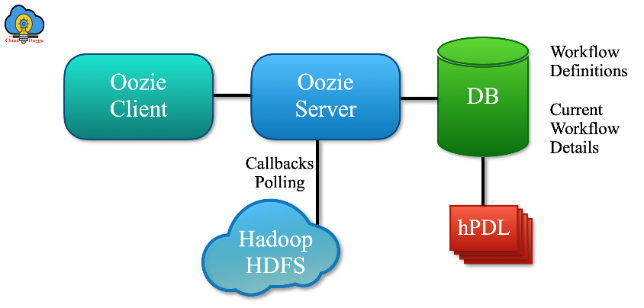

**Apache Oozie: Workflow**

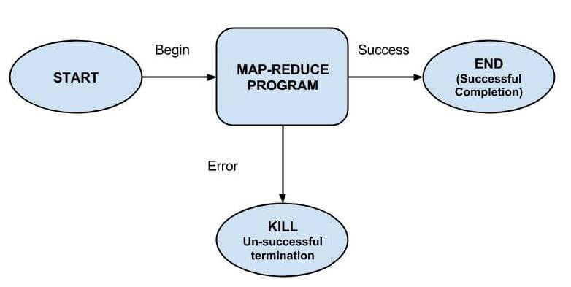

**Apache Oozie: Use Cases**

* Managing complex ETL pipelines.
* Orchestrating Hadoop jobs across multiple tools.
* Scheduling batch processing workflows.
* Co-ordinating real-time data workflows.

**Advantages:**

* Seamless integration with Hadoop.
* Scalable and fault-tolerant architecture.

**Limitations:**

* Limited to Hadoop ecosystem.
* Requires XML-based workflow definitions.

**Apache Spark: Introduction**

* Apache Spark is an open-source cluster computing framework designed for efficient data analytics.
* It supports in-memory cluster computing, making it significantly faster for iterative tasks.
* Spark offers high-level tools such as Spark Streaming for real-time data, Spark SQL for structured data analysis, MLlib for machine learning, GraphX for graph processing, and Shark (Hive on Spark) for SQL-like queries.
* It enables real-time, batch, and interactive queries, providing APIs for Scala, Java, and Python, making it versatile for a wide range of data processing applications.

**Apache Spark: Features**

1. In-memory computation for faster processing

Spark processes data in memory, reducing disk I/O and speeding up iterative tasks enabling faster execution for complex computations.

1. APIs for Python, Java, Scala, and R

Spark provides APIs in Python, Java, Scala, and R, allowing flexibility for users. This broadens Spark's usability.

1. Fault tolerance with data lineage

Spark uses data lineage to track transformations enhancing both efficiency and reliability.

1. Libraries for SQL, ML, Streaming, and GraphX

Spark includes libraries like Spark SQL, MLlib, Spark Streaming, and GraphX for processing structured data, machine learning, real-time analytics, and graph computation.

**Apache Spark: Architecture**

* Driver Program: Manages the Spark application and distributes tasks.
* Executors: Execute tasks and store data.

Cluster Manager: Allocates resources (e.g., YARN, Mesos).

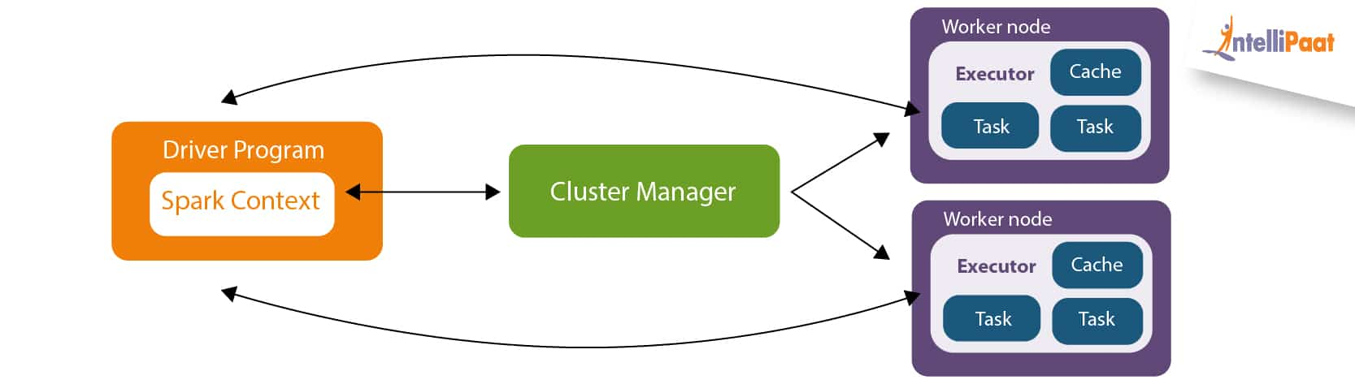

**Apache Spark: Resilient Distributed Datasets**

**RDDs (Resilient Distributed Datasets) are fault-tolerant collections of data processed in parallel across a cluster. They track lineage for recovery in case of failures, ensuring scalability and resilience in large-scale processing.**

**KEY FEATURES**

1. Lazy evaluation of transformations:   
   Spark delays the execution of transformations until an action is called, optimizing performance by reducing unnecessary computation and enabling more efficient data processing.
2. Immutable and distributed data partitions:   
   Data in Spark is divided into immutable partitions, distributed across the cluster, ensuring parallel processing and fault tolerance for scalable performance.

**Apache Spark: Core Libraries**

* Spark SQL: Structured data processing.
* MLlib: Scalable machine learning.
* Spark Streaming: Real-time data streams.
* GraphX: Graph computation and visualization.

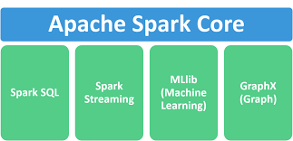

**Spark SQL**

* Spark SQL is a module for structured data processing in Apache Spark.
* It provides a programming abstraction called Data Frames and integrates seamlessly with big data tools.

FEATURES

* Supports SQL queries on structured data.
* Integrates with Hive for data querying.
* Enables conversion between DataFrames and RDDs.

**MLlib**

* MLlib is Spark’s scalable machine learning library.
* It provides tools for building and deploying machine learning models on large-scale datasets.

FEATURES

* Offers algorithms for classification, regression, clustering, and recommendation.
* Integrates with DataFrames for ease of use.
* Supports distributed training and evaluation of models.

**Spark Streaming**

* Spark Streaming is used for processing real-time data streams.
* It processes data in small batches to enable fault-tolerant, high-throughput stream processing.

**FEATURES**

* Supports data from sources like Kafka, Flume, and HDFS.
* Provides windowed computations and event-time processing.
* Allows integration with batch processing using the same API.

**GraphX**

* GraphX is Spark's API for graph and graph-parallel computations.
* It allows users to create, manipulate, and query graphs using RDDs.

FEATURES

* Supports Pregel API for graph-parallel computations.
* Provides built-in algorithms like PageRank and Connected Components.
* Allows seamless integration with Spark’s RDDs and DataFrames.

**Apache Spark: Applications**

* Real-time data analytics.
* ETL pipelines for large datasets.
* Machine learning model training.
* Social network analysis with GraphX.

**Advantages**:

- High-speed in-memory processing.

- Rich ecosystem of libraries.

**Limitations:**

- Requires high memory for optimal performance.

- Complex configurations for large-scale deployments.

**Apache Storm**

Apache Storm is a distributed, real-time stream processing framework that has revolutionized the way businesses handle data. Initially developed by BackType and later open-sourced by Twitter, it offers a robust, scalable, and fault-tolerant system for processing large volumes of unbounded data streams. As data generation continues to increase at unprecedented rates, the need for tools like Apache Storm has become crucial in ensuring real-time insights and actions. This framework is designed to process data as it arrives, making it an indispensable tool for industries where low latency and continuous data processing are critical.

**History and Evolution**

Apache Storm has its roots in a project developed by Nathan Marz while working at BackType, a company focused on social media analytics. BackType needed a system capable of processing vast amounts of real-time data generated by social media platforms. This requirement led to the creation of Storm, which provided a distributed, fault-tolerant framework for real-time data processing. When Twitter acquired BackType in 2011, Storm became a part of its technological arsenal to process the enormous data streams generated by its platform. Recognizing its potential beyond internal use, Twitter open-sourced Apache Storm in September 2011, making it accessible to a global developer community.

Following its open-sourcing, Apache Storm quickly gained popularity in the big data ecosystem. In 2014, it graduated as a top-level project under the Apache Software Foundation, solidifying its place among leading open-source technologies. Over the years, it has evolved to include advanced features such as improved resource scheduling, enhanced fault tolerance, and better integration with tools like Apache Kafka and Hadoop. While newer stream processing frameworks have emerged, Apache Storm remains a significant player due to its simplicity, robust architecture, and proven effectiveness in real-time data processing scenarios. Its evolution reflects the growing need for technologies capable of handling the complexities of modern data streams.

**Key Features of Apache Storm**

Here are the key features of Apache Storm:

1. **Real-Time Processing**  
   Apache Storm excels in processing data as it arrives, providing near-instantaneous insights, making it ideal for time-sensitive applications like fraud detection or live monitoring.
2. **Distributed Architecture**  
   It is designed to work across multiple nodes in a cluster, ensuring high performance and scalability by distributing processing tasks.
3. **Fault Tolerance**  
   Apache Storm automatically detects and handles failures. Failed tasks are reassigned to other nodes without data loss, ensuring high availability and reliability.
4. **Scalability**  
   The framework supports horizontal scaling, allowing organizations to increase processing capacity by adding more nodes to the cluster.
5. **Event-Driven Processing**  
   It is designed to process continuous streams of data, enabling real-time applications that require constant data ingestion and transformation.
6. **Low Latency**  
   Apache Storm provides sub-second latency, making it suitable for applications where speed is critical.
7. **Language Support**  
   Developers can write Storm topologies in multiple programming languages, including Java, Python, Ruby, and others, enhancing accessibility and flexibility.
8. **Easy Integration**   
   Apache Storm integrates seamlessly with big data tools like Apache Kafka, HDFS, Cassandra, and NoSQL databases, creating a cohesive data ecosystem.
9. **Stream Processing Topologies**   
   Storm organizes data processing workflows into topologies consisting of Spouts (data sources) and Bolts (data processors), providing a clear and modular design.
10. **Guaranteed Data Processing**  
    With mechanisms like acknowledgment (ACK) and tuple tracking, Apache Storm ensures that every piece of data is processed at least once.
11. **Stateless and Stateful Processing**  
    Supports both stateless and stateful processing, catering to various use cases and levels of complexity.
12. **Dynamic Scaling**  
    Topologies can dynamically scale up or down depending on the workload, optimizing resource usage.
13. **Fault Recovery**  
    In case of hardware or software failure, Storm automatically restarts the processing tasks, maintaining system resilience.
14. **Open Source and Community Support**  
    As an Apache project, Storm benefits from a strong developer community, frequent updates, and extensive documentation.
15. **Pluggable Scheduler**  
    Apache Storm provides a pluggable scheduling mechanism, enabling users to customize how tasks are assigned to nodes in the cluster.
16. **Metrics and Monitoring**  
    It includes built-in tools for monitoring and debugging topologies, helping maintain operational efficiency.
17. **Batch Processing with Trident**  
    The Trident API extends Apache Storm’s functionality to support micro-batch processing and stateful computations.
18. **High Throughput**  
    Designed to handle millions of tuples per second per node, ensuring it can meet the demands of high-volume data streams.
19. **Flexible Deployment**  
    Apache Storm can run in various environments, including on-premises, cloud platforms, and containerized setups like Docker.
20. **Backpressure Mechanism**  
    Prevents system overload by controlling the flow of data between components during heavy loads.

These features make Apache Storm a versatile and reliable framework for building real-time, scalable, and fault-tolerant data processing systems.

**Apache Storm Architecture**

Apache Storm’s architecture is designed to handle the real-time processing of unbounded streams of data in a distributed and fault-tolerant manner. Its core components work together to enable the creation of flexible, scalable, and reliable data processing workflows. Below is an explanation of its major architectural components:

**1. Topologies**

* A **topology** represents the overall data processing workflow in Apache Storm. It is a directed acyclic graph (DAG) where:
  + **Nodes** represent computation components (Spouts and Bolts).
  + **Edges** represent the flow of data between components.
* Unlike batch processing frameworks, topologies in Storm run continuously until explicitly terminated, processing data streams in real time.

**2. Spouts**

* Spouts are the data sources in a topology.
* They read or pull data from external systems like message queues (e.g., Apache Kafka), databases, or APIs.
* Spouts emit data in the form of **tuples**, which are basic data units processed by the system.
* Spouts can be either **reliable** (acknowledge processing of data) or **unreliable** (fire-and-forget).

**3. Bolts**

* Bolts are the data processors in a topology.
* They perform a variety of operations such as filtering, aggregating, joining, or transforming data.
* Bolts can receive input tuples from multiple Spouts or other Bolts and emit output tuples to subsequent components.
* They enable the building of complex data processing pipelines by chaining multiple Bolts together.

**4. Stream Manager (or Nimbus)**

* Nimbus is the master node in Apache Storm.
* It is responsible for:
  + Distributing topology code across the cluster.
  + Assigning tasks to worker nodes.
  + Monitoring cluster performance and restarting failed tasks.
* Nimbus operates similarly to the JobTracker in Hadoop but is focused on real-time processing.

**5. Supervisors**

* Supervisors are worker nodes in the cluster.
* They are responsible for executing tasks assigned to them by Nimbus.
* Each Supervisor manages a set of worker processes, which in turn handle the execution of specific topology components.

**6. Worker Processes**

* Worker processes are responsible for executing specific Spouts and Bolts.
* Each worker process can run multiple threads, allowing multiple tasks to execute concurrently.

**7. Zookeeper**

* Zookeeper acts as a coordination and communication service in Apache Storm.
* It is responsible for:
  + Managing the state of the cluster (e.g., tracking active nodes and tasks).
  + Facilitating communication between Nimbus and Supervisors.
  + Ensuring the reliability and fault tolerance of the system.

**8. Tuple**

* A tuple is the basic data unit in Apache Storm.
* It consists of a set of named fields that carry the data being processed.
* Tuples flow through the topology from Spouts to Bolts.

**9. Stream Grouping**

* Stream grouping determines how tuples are distributed from one component to another.
* Common grouping strategies include:
  + **Shuffle Grouping**: Randomly distributes tuples.
  + **Field Grouping**: Distributes tuples based on a specific field value.
  + **All Grouping**: Sends each tuple to all downstream components.
  + **Global Grouping**: Sends tuples to a single Bolt.

**10. Fault Tolerance**

* Storm ensures fault tolerance by tracking tuple processing using its ACK framework.
* If a tuple fails to be processed successfully, it is re-emitted to ensure data integrity.

**Diagram of Apache Storm Architecture**

The architecture can be visualized as:

1. **Nimbus** distributes tasks to **Supervisors**.
2. Supervisors manage **worker processes** running Spouts and Bolts.
3. Zookeeper ensures cluster state consistency.
4. Tuples flow through Spouts → Bolts according to the defined topology.

Apache Storm's architecture enables it to process data in real time, making it a reliable and efficient framework for diverse applications such as real-time analytics, monitoring, and machine learning pipelines.

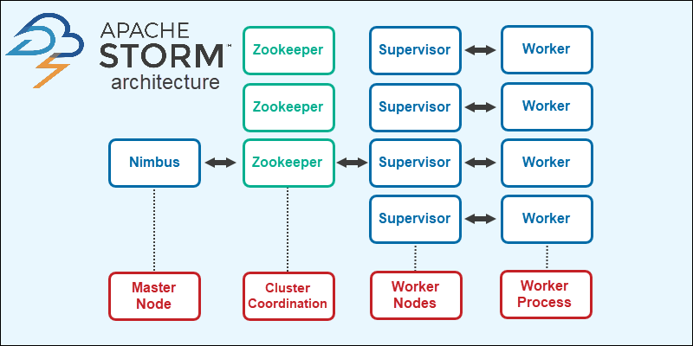

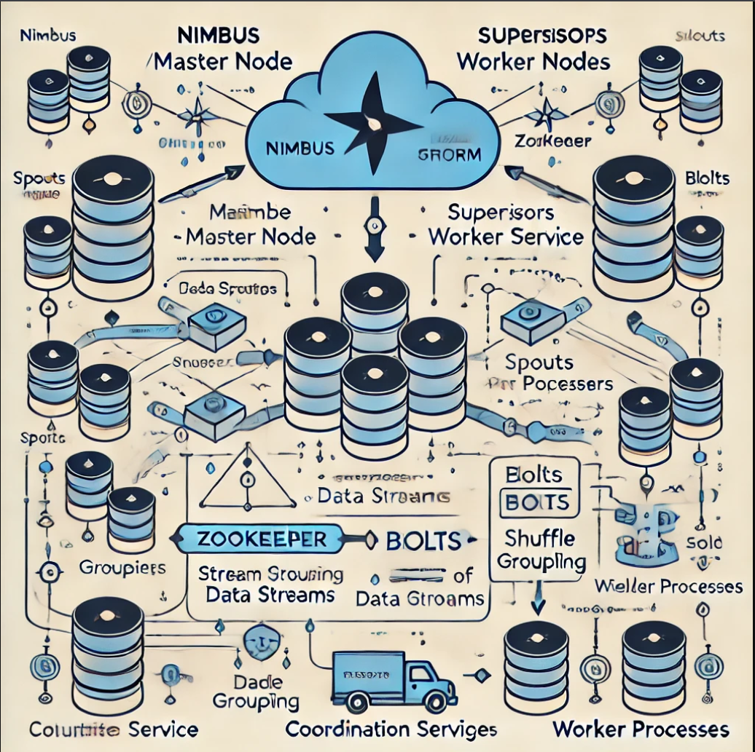

**Data Processing Workflow in Apache Storm**

Apache Storm processes data in real-time using a defined workflow that involves multiple stages of data ingestion, processing, and output. This workflow is constructed using a **topology**, which connects data sources (Spouts) and processing units (Bolts) in a directed acyclic graph (DAG). Below is a step-by-step breakdown of the data processing workflow:

**1. Data Ingestion (Spouts)**

* The workflow begins with **Spouts**, which act as the data ingestion points in the topology.
* Spouts read data from external systems such as:
  + Message queues (e.g., Apache Kafka or RabbitMQ).
  + Databases or APIs.
  + Files or logs.
* Spouts emit data as **tuples** into the topology, making it available for processing.
* Depending on the use case, Spouts can operate in:
  + **Reliable mode**: Acknowledges tuples only after they are successfully processed.
  + **Unreliable mode**: Emits data without waiting for acknowledgments.

**2. Data Processing (Bolts)**

* Once emitted by Spouts, tuples are passed to **Bolts**, the core processing units in Apache Storm.
* Bolts perform operations such as:
  + **Filtering**: Removing irrelevant data.
  + **Transformation**: Converting data into a usable format.
  + **Aggregation**: Summarizing data, such as counting occurrences.
  + **Joining**: Merging streams from multiple sources.
  + **Enrichment**: Adding context to data by fetching additional information.
* Bolts can emit new tuples after processing, passing them to subsequent Bolts for further computation.

**3. Data Routing (Stream Grouping)**

* As tuples flow from Spouts to Bolts or between Bolts, Apache Storm uses **Stream Grouping** to determine how data is distributed. Common strategies include:
  + **Shuffle Grouping**: Distributes tuples randomly for load balancing.
  + **Field Grouping**: Routes tuples to specific Bolts based on the value of a field (e.g., all data for a particular user).
  + **All Grouping**: Broadcasts tuples to all downstream components.
  + **Direct Grouping**: Sends tuples to specific tasks, as defined programmatically.

**4. Data Acknowledgment (ACKing)**

* Apache Storm tracks the processing of tuples using an acknowledgment (ACK) framework.
* Each tuple is monitored to ensure it is processed successfully.
* If a tuple fails during processing, Storm automatically retries it to maintain data integrity.

**5. Data Emission**

* After processing, Bolts can emit processed data tuples to:
  + Other Bolts for further computation.
  + External systems like databases, dashboards, or file storage for final output.
* The topology continues to process data streams continuously in real-time.

**Example Workflow**

1. A Spout reads messages from a Kafka topic and emits them as tuples.
2. A Bolt filters the tuples to include only relevant events (e.g., transactions over a specific amount).
3. Another Bolt aggregates the data, calculating real-time metrics like the total transaction value.
4. The final Bolt stores the aggregated results in a database or sends them to a live dashboard for visualization.

The Apache Storm data processing workflow is highly modular and customizable, enabling developers to build robust pipelines tailored to specific use cases, such as fraud detection, real-time recommendations, and anomaly detection. Its continuous processing model ensures low latency and high throughput, making it an ideal choice for real-time applications.

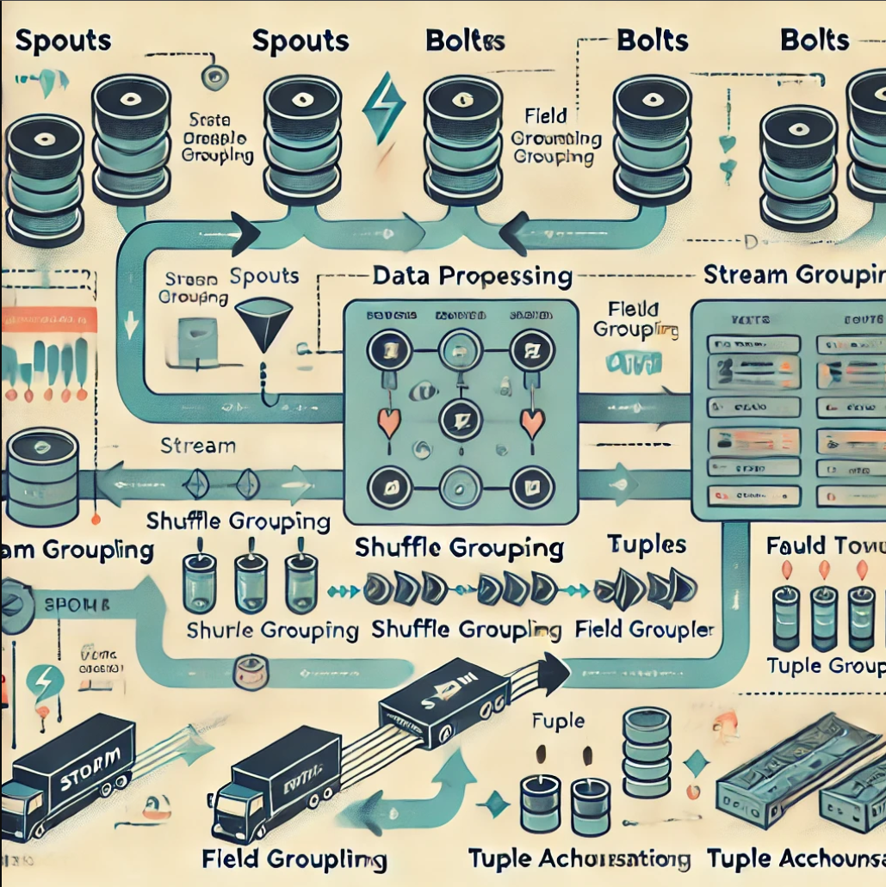

**Use Cases of Apache Storm**

Apache Storm is widely used in various industries to process real-time data streams and derive actionable insights. Its versatility and low-latency processing capabilities make it an excellent choice for diverse applications. Here are some key use cases:

**1. Real-Time Analytics**

* **Description**: Apache Storm powers real-time analytics by processing and analyzing data streams as they arrive.
* **Examples**:
  + Tracking customer behavior on e-commerce platforms.
  + Analyzing website traffic and clickstream data.
  + Monitoring financial markets for price fluctuations and trends.

**2. Fraud Detection**

* **Description**: Detecting fraudulent activities in real-time by analyzing transaction patterns and anomalies.
* **Examples**:
  + Banking systems using Storm to identify unusual transaction patterns.
  + Credit card companies monitoring real-time spending for fraud alerts.
  + E-commerce platforms flagging fake reviews or activities.

**3. Operational Monitoring and Alerting**

* **Description**: Monitoring systems and generating alerts for anomalies or critical conditions.
* **Examples**:
  + Network performance monitoring in telecommunications.
  + Infrastructure monitoring for cloud systems to detect outages or resource overuse.
  + Application performance management (APM) tools providing real-time updates on software health.

**4. Recommendation Systems**

* **Description**: Generating personalized recommendations based on user behavior in real-time.
* **Examples**:
  + Streaming platforms (e.g., Netflix, Spotify) suggesting content based on viewing or listening habits.
  + E-commerce platforms displaying “products you may like” during browsing.

**5. Social Media Analytics**

* **Description**: Processing massive amounts of real-time data from social media platforms.
* **Examples**:
  + Sentiment analysis for trending topics or brand mentions.
  + Real-time tracking of user engagement metrics like likes, shares, and comments.
  + Identifying influencers or viral content.

**6. IoT Data Processing**

* **Description**: Handling continuous data streams from Internet of Things (IoT) devices.
* **Examples**:
  + Smart homes analyzing sensor data for automation.
  + Industrial IoT systems monitoring equipment performance and predicting failures.
  + Traffic management systems optimizing routes based on live traffic data.

**7. Online Advertising**

* **Description**: Optimizing ad targeting and bidding in real-time.
* **Examples**:
  + Real-time bidding platforms analyzing user profiles for targeted advertisements.
  + Ad networks measuring campaign performance metrics instantly.

**8. Log Processing**

* **Description**: Analyzing logs from servers, applications, and services for insights.
* **Examples**:
  + Real-time error detection and alerting in software systems.
  + Security log analysis to identify breaches or suspicious activities.
  + Analyzing website logs for usage patterns and optimizations.

**9. Gaming Analytics**

* **Description**: Enhancing user experience and performance monitoring in online gaming.
* **Examples**:
  + Tracking player behavior to offer tailored challenges or rewards.
  + Monitoring game server performance and detecting anomalies.
  + Real-time leaderboards and event notifications.

**10. Healthcare Applications**

* **Description**: Processing data streams from wearable devices and medical equipment.
* **Examples**:
  + Real-time monitoring of patient vitals in hospitals.
  + Wearable fitness trackers analyzing and reporting activity metrics.
  + Early detection of health risks using continuous data analysis.

Apache Storm's real-time processing capabilities have made it a vital tool for industries that require instant insights and actions. Its flexibility to integrate with other systems and support for large-scale data processing ensures its relevance across various domains.

**Example Application: Word Count Topology**

A simple example of an Apache Storm application is a real-time word count topology. Here's how it works:

1. **Data Source:** A spout reads sentences from a message queue.
2. **Sentence Splitter Bolt:** This bolt splits each sentence into words.
3. **Word Counter Bolt:** This bolt counts the occurrences of each word and updates a database.

The application continuously processes incoming sentences, updating word counts in real time.

**Advantages of Apache Storm**

* **Real-Time Processing:** It provides near-instant processing of large data streams.
* **Fault Tolerance:** Built-in fault tolerance ensures data processing continuity.
* **Scalability:** Horizontal scaling supports processing billions of events per day.
* **Extensibility:** Easy integration with other big data tools like Kafka and Hadoop.
* **Open Source:** Free and open-source, backed by an active community.

**Challenges and Limitations**

Despite its advantages, Apache Storm has some limitations:

* **Complex Setup:** Installing and managing a Storm cluster can be complex.
* **High Resource Consumption:** It requires significant memory and CPU resources.
* **Processing Guarantees:** While Storm ensures at-least-once processing, achieving exactly-once semantics requires extra work.
* **Learning Curve:** Developers need to understand distributed systems concepts.

**Comparing Apache Storm with Other Tools**

| **Feature** | **Apache Storm** | **Apache Kafka Streams** | **Apache Spark Streaming** |
| --- | --- | --- | --- |
| Processing Model | Real-time | Real-time | Micro-batch |
| Fault Tolerance | Built-in | Built-in | Built-in |
| Scalability | High | High | High |
| Use Cases | Real-time analytics | Event streaming | Batch + Streaming |
| Latency | Low (ms-level) | Low (ms-level) | Higher (seconds-level) |